TYPES OF HYPERSENSITIVITY REACTIONS

Written Table

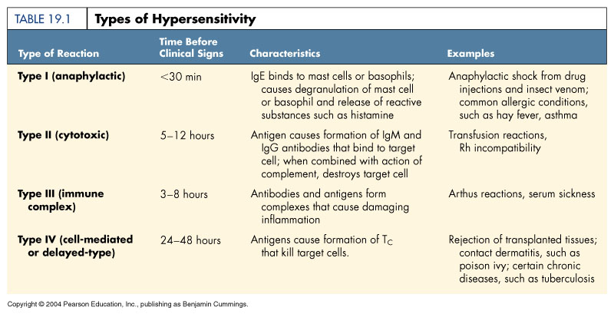

Illustrated Table

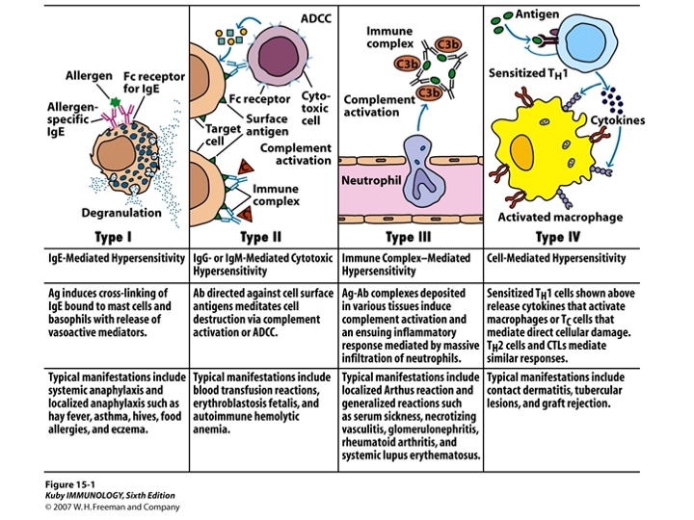
DermNet NZ

Type I hypersensitivity reaction
Type I hypersensitivity reaction is the most widely known type of allergic reaction and includes anaphylaxis; this is where the body reacts to a stimulus, or allergen, leading to swelling of the airways, and cardiovascular and other organ system effects. True anaphylaxis is uncommon.
Anaphylaxis occurs when a specific type of antibody, immunoglobulin E (IgE), recognises a foreign antigen and attaches itself to it. By attaching to the antigen, the IgE activates a chain of reactions that result in the widespread release of chemicals, including histamine.
Type I hypersensitivity reactions include:
- Food allergies, such as peanuts and shellfish
- Oral allergy syndrome
- Bee sting reactions
- Penicillin allergy
- Latex allergy.

Type II hypersensitivity reaction
Type II hypersensitivity reactions, or autoimmune reactions, are due to the abnormal binding of antibodies to normal host targets. Autoimmune diseases involve immunoglobulin G (IgG) and M (IgM) antibodies that activate the complement cascade. This causes inflammation and damage to tissues.
Cutaneous examples of type II hypersensitivity reactions include:
- Bullous pemphigoid
- Pemphigus vulgaris.

Type III hypersensitivity reaction
Type III hypersensitivity reaction involves IgG antibodies bound to foreign antigens in the blood. These antibody–antigen complexes can precipitate and get stuck in certain locations, such as blood vessels in the skin, kidneys and joints, where they activate the complement cascade to cause local damage.
Common cutaneous examples of type III hypersensitivity reactions include:
- Henoch–Schönlein purpura
- Small-vessel vasculitis
- Systemic lupus erythematosus
- Rheumatoid arthritis
- Serum sickness.
Most commonly, immune-complex reactions cause palpable purpura, the hallmark of small-vessel vasculitis. These are visible, non-blanching haemorrhages that are raised and palpable on examination.

Type IV hypersensitivity reaction
Type IV hypersensitivity or delayed hypersensitivity reaction occurs 48–72 hours after exposure to the allergen. This reaction does not involve antibodies. Instead, eosinophils, monocytes, or lymphocytes called T cells are activated by the antigen. The helper CD4+ T cells initially recognise the antigen, releasing cytokines that activate the immune system with killer CD8+ T cells to destroy the target cells on contact, and macrophages to wall off the antigen and prevent further damage.
Common examples of cutaneous type IV hypersensitivity reactions include:
- Allergic contact dermatitis — commonly to hair dye, nickel in jewellery, Toxicodendron spp.(eg, poison ivy, Rhus)
- The Mantoux test (used to detect active tuberculosis)
- Delayed drug reactions, including:
  - Morbilliform drug reactions
  - Drug hypersensitivity syndrome (formerly known as drug reaction with eosinophilia and systemic symptoms [DRESS])
  - Erythema multiforme
  - Lichenoid drug eruptions
  - Steven–Johnson syndrome (SJS) / toxic epidermal necrolysis (TEN).

